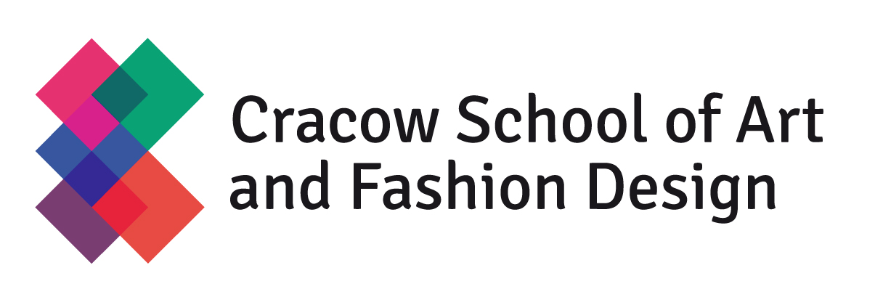

SCHOOL REGULATIONS
I hereby certify that I have read the School’s Terms & Conditions, its status and rules. I particularly acknowledge the following rules:
- Education at Cracow School of Art and Fashion Design is subject to education fees.
- The registration fee is a not-refundable deposit to guarantee a place at the School. The registration fee is valid for 5 years.
- The tuition fee for the first semester will be refunded (less handling and bank costs) only in case if a student doesn’t obtain a Polish visa. No allowance is made for non attendance.
- If a student has started education online or in the school building and took part in the classes, the tuition fee is not refunded.
- Tuition fees should be paid every semester.
a) Fee for the winter semester must be paid before the 15th of September and fee for the spring semester must be paid before 15th of February.
b)The evidence of payment should be presented at the Teaching Department.
c) If the tuition fees are not paid at dates above, the student will be suspended.
d) In order to get reinstated to the student list, the suspended student must submit a written request,
confirmation of payment of tuition fee and pay 50 EUR for reactivation costs.
e) Fees are revised annually with every effort to keep increases to a minimum.
f) The fees do not include the cost of materials necessary for attending classes such as paints, drawing paper, fabrics for collection, although the school may occasionally provide some necessary materials for students.
- Not attending classes does not relieve students from payment of tuition fees.
- If student doesn't pass credits or exams at the first obligatory dates, he/she is obliged to cover payment of 19 Euros for extra exams or credits before attending them.
- Graduation fee of 170 Euros has to be paid before diploma exam.
- Satisfactory progress is crucial in order to continue education and receive a diploma.
- Students can not be absent at more than two classes of a given subject during the semester. In the case of greater absence the Lecturer may not allow the student to participate in exam session.
- Design works, paintings, drawings made under the supervision of the School are the property of the School. Projects pursued using School materials are the property of the School. Projects pursued using Student’s materials are the property of the Student.
- The School is not responsible for the loss or destruction of works sent for exhibitions.

